**1. HOW TO DEPLOY SPRING BOOT APPLICATION IN AWS**

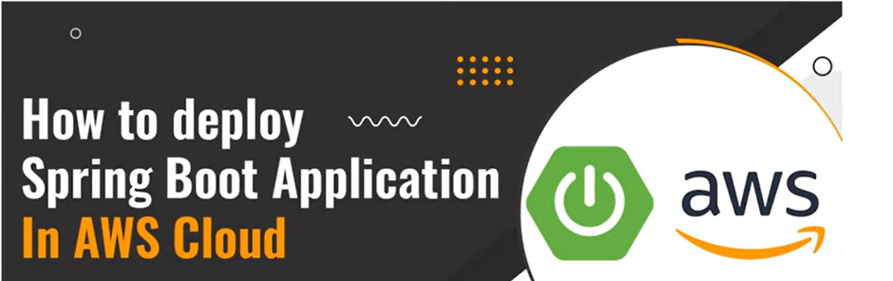

**2. WHAT IS SPRING BOOT**

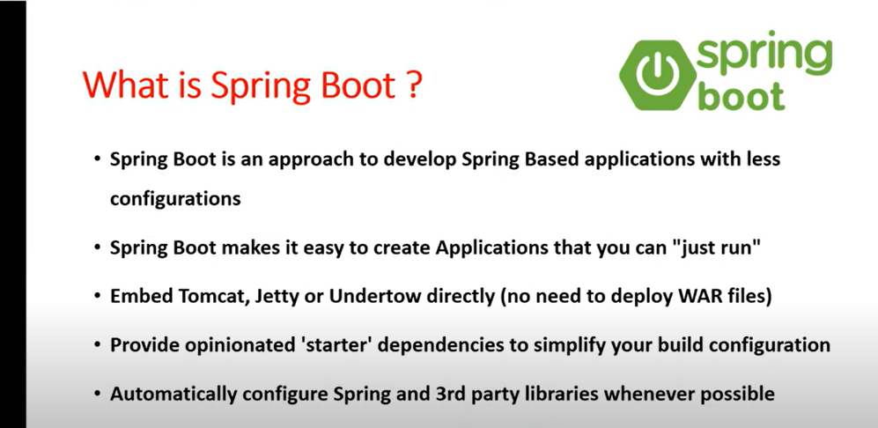

**# CONFIGURATION TAKEN CARE BY SPRING BOOT.**

**# SPRING BOOT PROVIDE EMBEDED CONTAINER LIKE TOMCAT, JETTY TO RUN OUR APPLICATION & WE NO NEED TO DOWNLOAD OR INSTALL SERVER TO RUN OUR WEB APPLICATION. YOU CAN JUST CREATE THE APPLICATION AND RUN THAT & DEPLOYMENT TAKEN CARE BY SPRING BOOT.**

**# ITS GOING TO PROVIDE "POM" STARTER TO SIMPLYFY MAVEN & GRADLE CONFIGURATION. FOR EXAMPLE YOU ARE DEVELOPING A WEB APPLICATION , YOU NO NEED TO ADD SO MANY DEPENDENCIES IN "POM.XML" JUST YOU ARE GOING TO ADD A WEB STATER & IT WILL TAKE CARE ALL REQUIRED DEPENDENCIES TO DEVELOP THE WEB APPLICATION USING SPRING BOOT.**

**# IT WILL CONFIURE SPRING FRAMEWORK.**

**3. PREREQUISITE OF SPRING BOOT APP TO DEPLOY IN AWS.**

**# CREATE SPRING BOOT APPLICATION**

**# PACKAGE BOOT APP USING "MAVEN"**

**# LAUNCH EC2 INSTANCE IN AWS**

**# CONNECT WITH EC2 INSTANCE USING "MOBAXTERM" OR "PUTTY"**

**# INSTALL JAVA IN EC2 INSTANCE**

**# UPLOAD "JAR" FILE IN TO EC2 VM**

**# RUN BOOT APPLICATION**

**# ACCESS APPLICATION IN BROWESER.**

**4. HERE I AM USING "SPRING TOOL SUITE SAME" AS "MS VSCODE" TO CREATE BOOT APPLICATION.**

**CLICK ON FILE..**

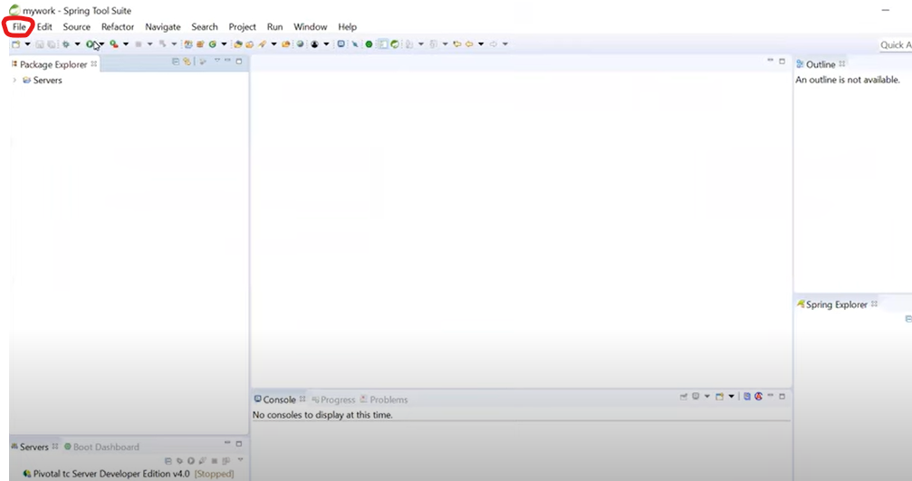

**5. CLICK NEW-SPRING STATER PROJECT**

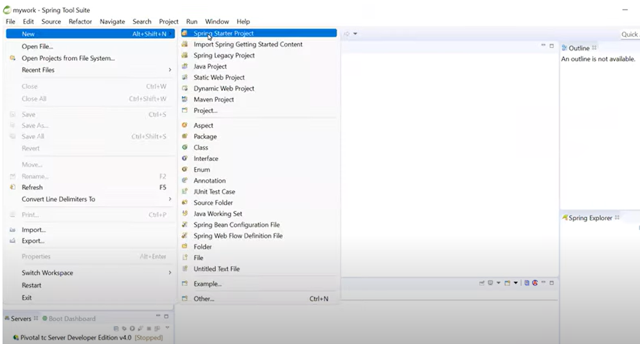

**6. BUILD TOOL I AM USING "MAVEN" & PACKAGING TYPE "JAR"**

**GROUP ID & PACKAGE (GIVE ANY SAME NAME) THEN CLICK NEXT BUTTON**

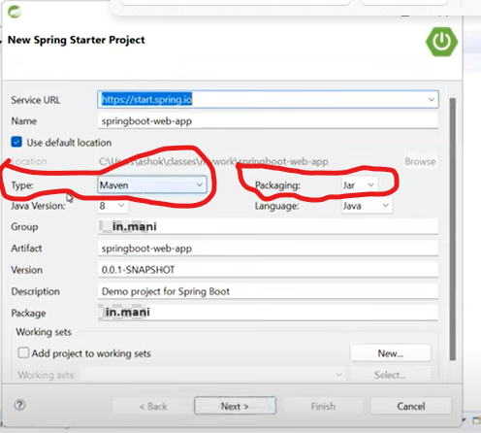

**7. SELECT LATEST VERSION & CHECK THE BOX "SPRING WEB" THEN NEXT & FINISH.**

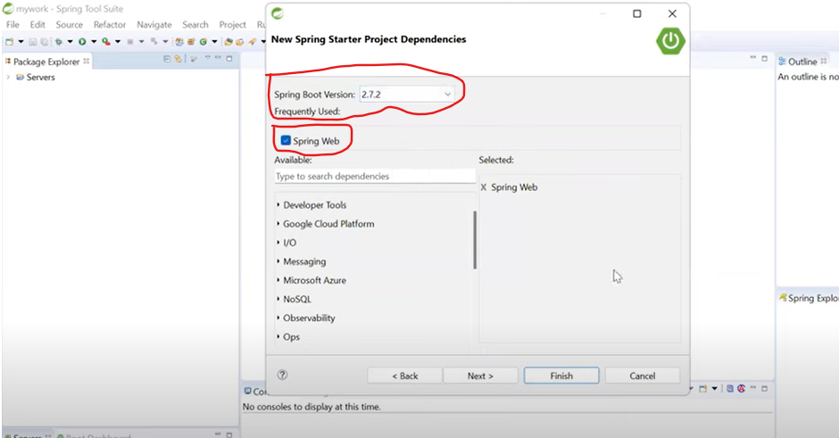

**8. BOOT APPLICATION GETTING CREATED HERE.**

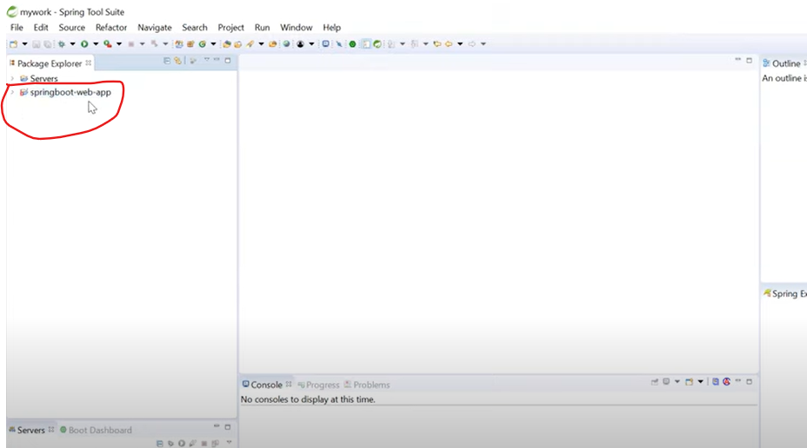

**9. IN BOOT APPLICATION I HAVE ADDED ONE "WEB STATER" THAT WILL PROVIDE SUPPORT TO DEVELOP THEWEB APPLICATION & IT WILL PROVIDE "TOMCAT" AS A DEFAULT EMBEDED CONTAINER**

**HERE ONE START CLASS HAS CREATED & START CLASS IS ENTRY POINT FOR BOOT APPLICATION EXECUTION**

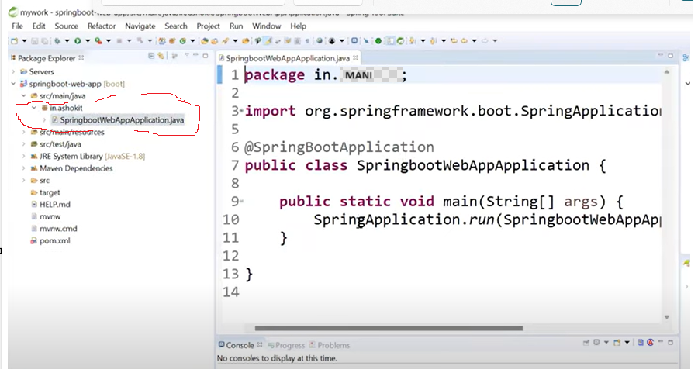

**10. LETS CREAT A REST CONTROLLER.**

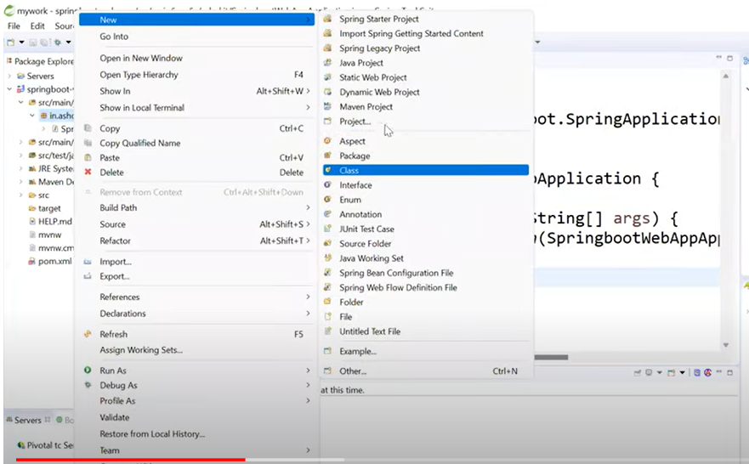

**11. GIVE HERE CONTOLLER NAME (ANY) & CLICK FINISH.**

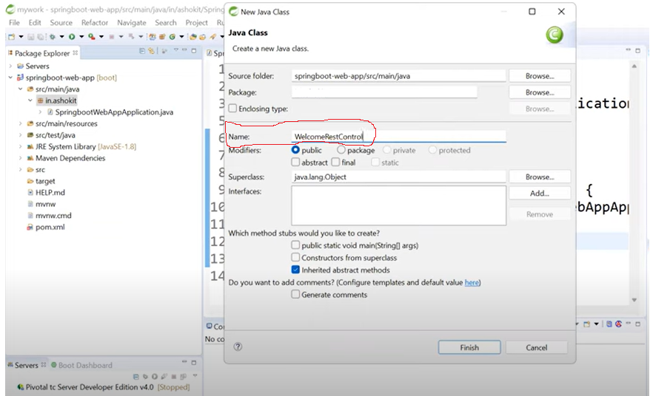

**12. SELECT YOUR CREATED CONTOLLER & WRITE ONE SAMPLE METHOD**

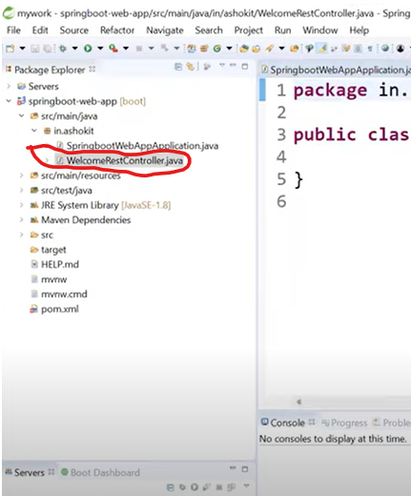

**13.**

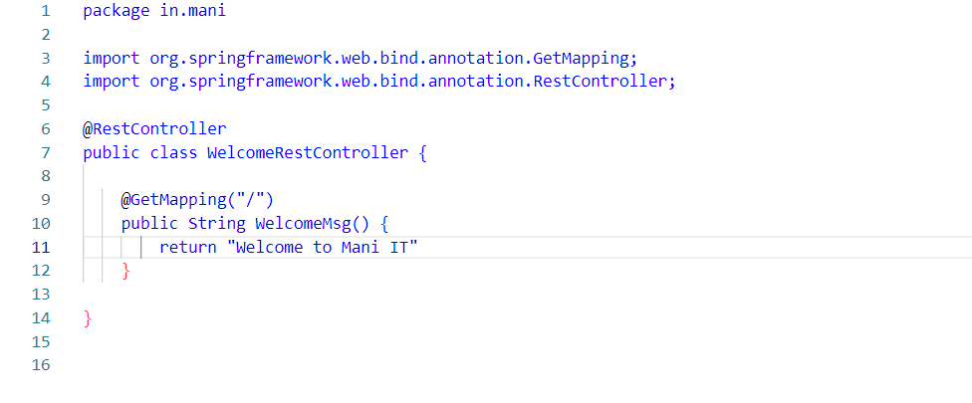

**14. NOW RUN THIS APPLICATION LOCAL**

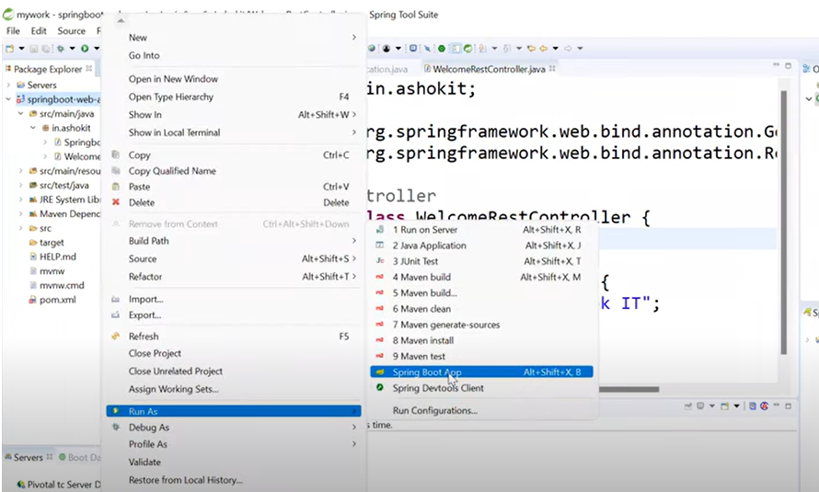

**15. NOW YOU SEE ON THE CONSOLE THE BOOT APPLICATION HAS STARTED & DEPLOYED IN TO TOMCAT SERVER WHICH RUNNING ON PORT NUMBER 8080.**

**TOMCAT IS COMING WITH SPRING BOOT AS EMBEDED CONTAINER.**

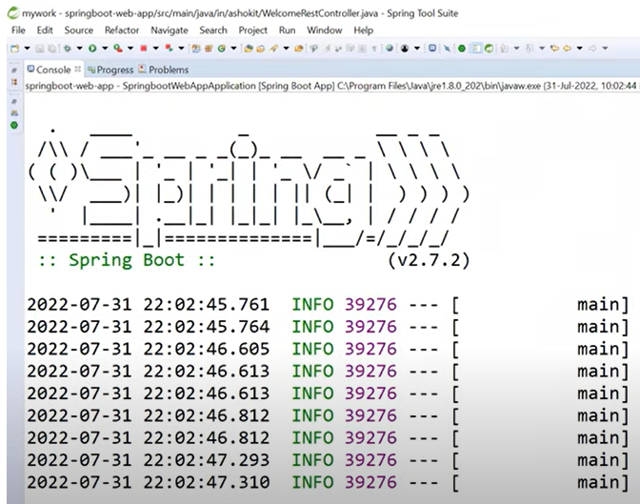

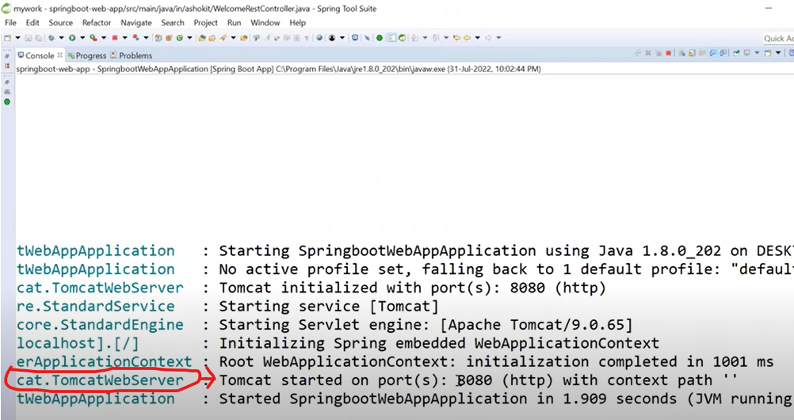

**16. NOW YOU CAN ACCESS THIS ON BROWSER LOCALLY**

**WITH "localhost:8080"**

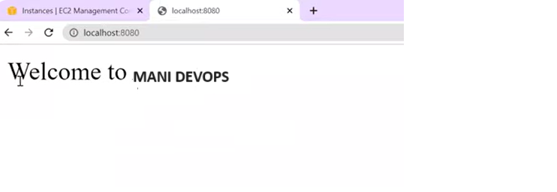**17. NOW SAME APPLIATION ACCESS IN AWS CLOUD & FOR THAT I AM LAUNCH ONE EC2 INSTANCE**

**CLICK ON "LAUNCH INSTANCE"**

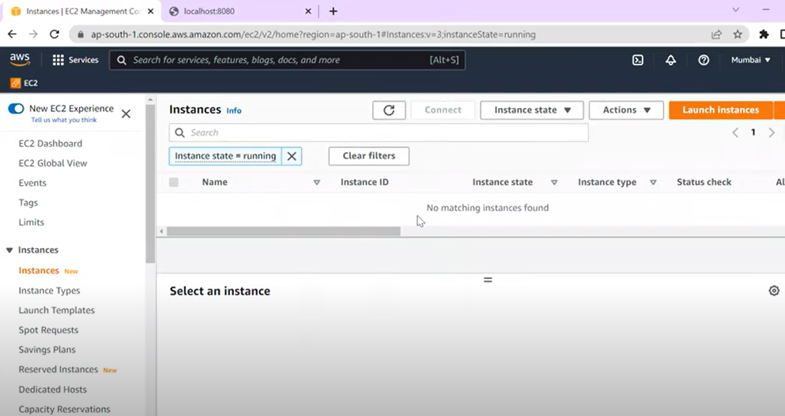

**18. SELECT AMAZON LINUX 2 AMI (HVM)**

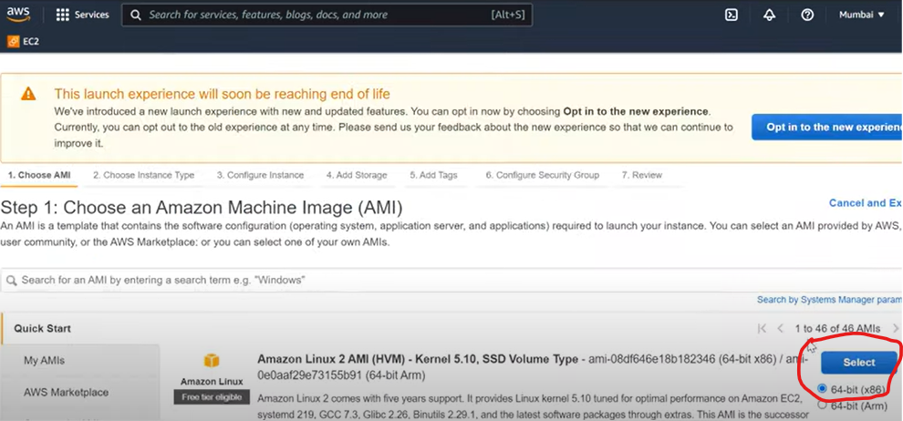

**19. SELECT T2 MICRO THEN CLICK NEXT**

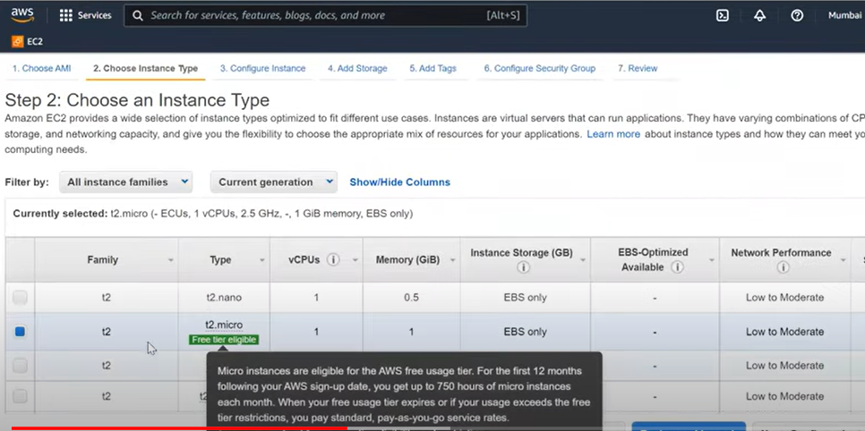

**20. CLICK NEXT**

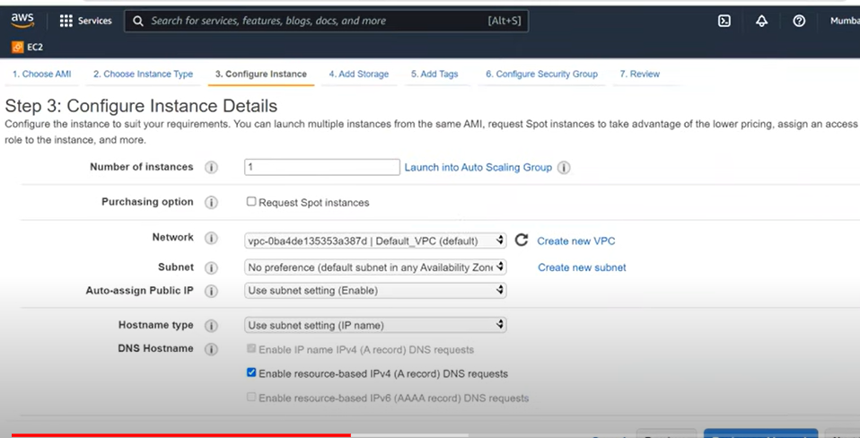

**21. CLICK NEXT**

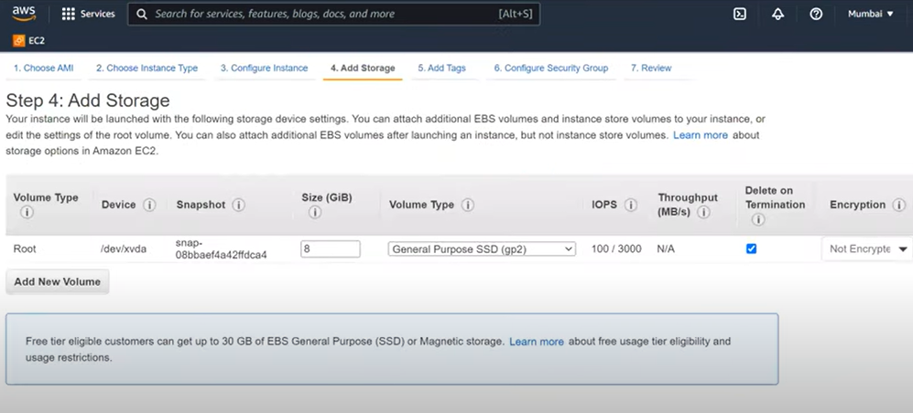

**22. TAG NAME IS OPTIONAL - CLICK NEXT**

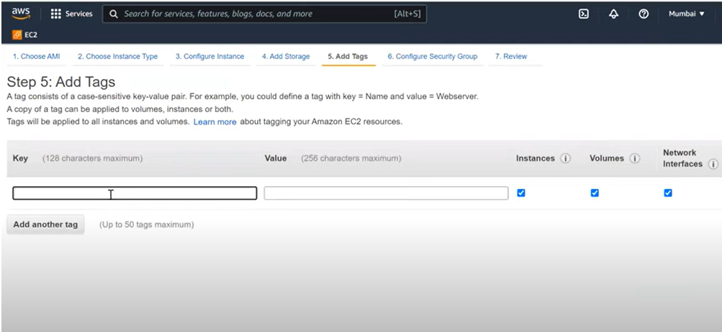

**23. SELECT DEFAULT SECURITY GROUP OR CREATE NEW ONE**

**NOTED : AWS Security Groups act like a firewall for your Amazon EC2 instances controlling both inbound and outbound traffic. When you launch an instance on Amazon EC2, you need to assign it to a particular security group**

**MAKE SSH PROTOCOL & TCP 8080 IS ENABLE IN INBOUND RULE**



**24. CLICK ON REVIEW AND LAUNCH**

**25. HERE ASK KEY ( IF YOU ARE HAVING EXISTING KEY THEN SELECT EXISTING OTHERWISE CREATE A NE KEY PAIR**

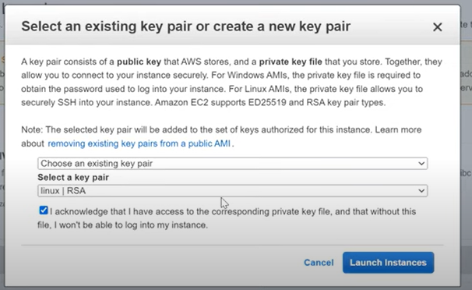

**26. NOW CLICK ON LAUNCH INSTANCE**

**27. EC2 INSTANCE CREATED & INSTANCE STATE CURRENTLY PENDING. WAIT FEW SECOND THE RUNNING STATE**

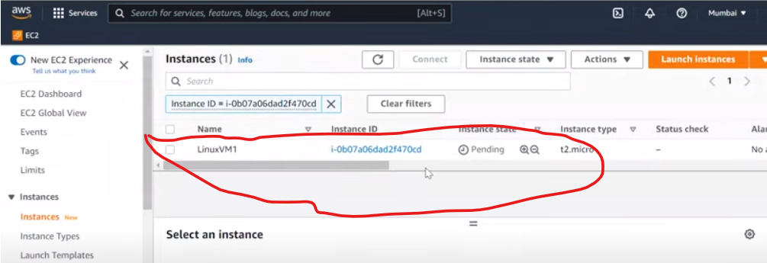

**28. NOW ITS RUNNING STATE**

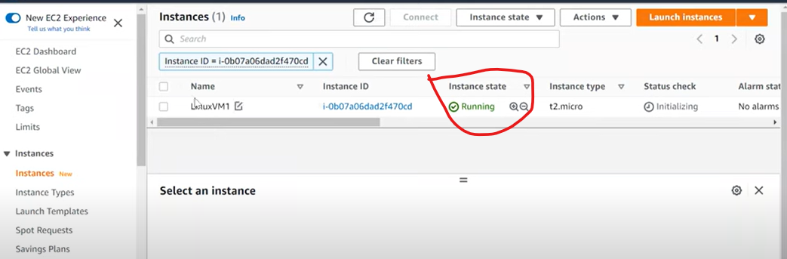

**29. NOW SELECT THIS INSTANCE**

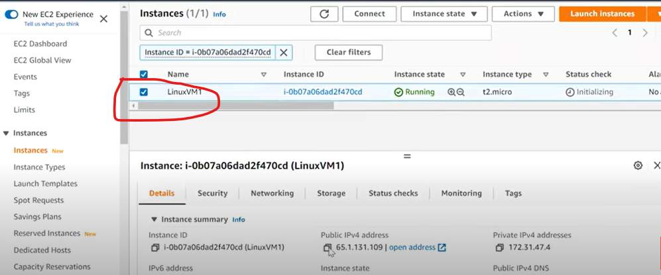

**30. COPY PUBLIC IP**

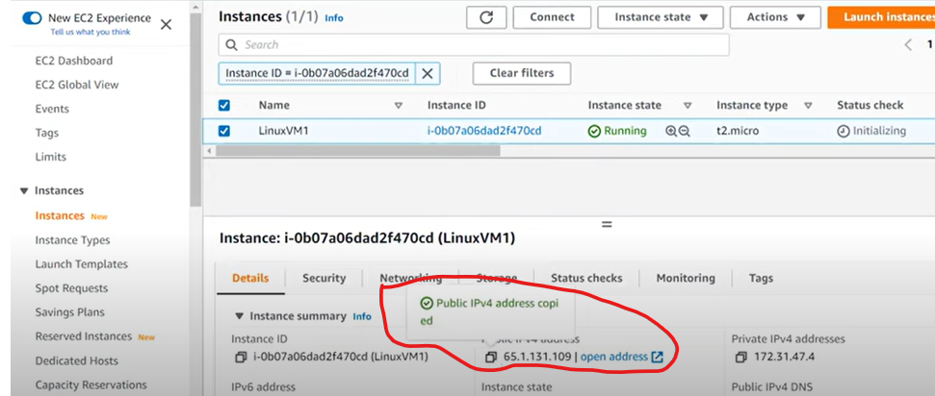

**31. NOW OPEN MOBAXTERM APP (WE CAN PUTTY ALSO USED)**

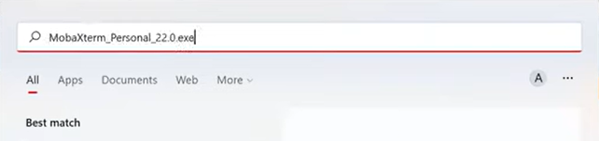

**32. NOW PAST PUBLIC IP IN REMOTE HOST & USER NAME (ec2-user)**

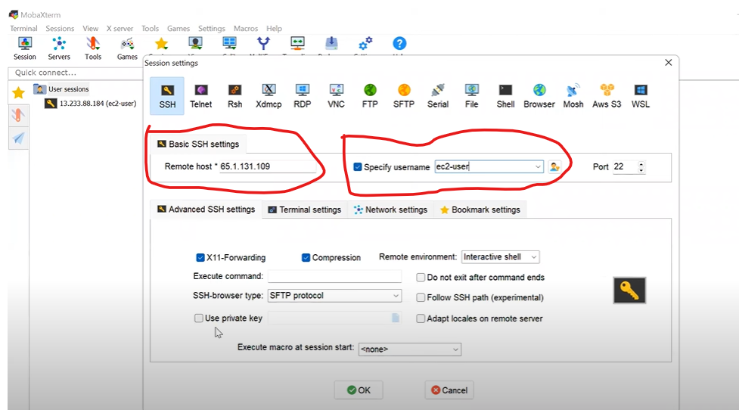

**33. NOW SELECT ADVANCED SSH SETTING & CLICK ON USE PRIVATE KEY**

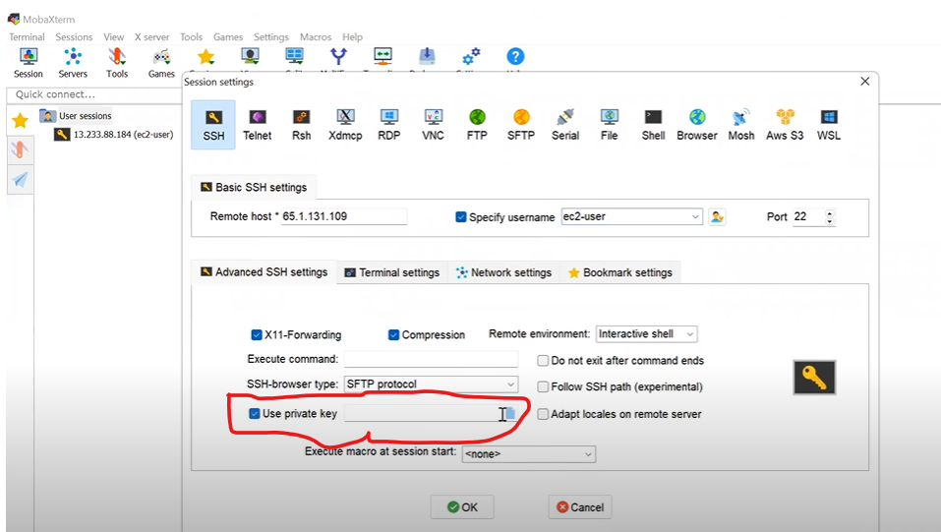

**34. NOW BROWSE YOUR PEM KEY & SELECT AND CLICK OPEN BUTTON**

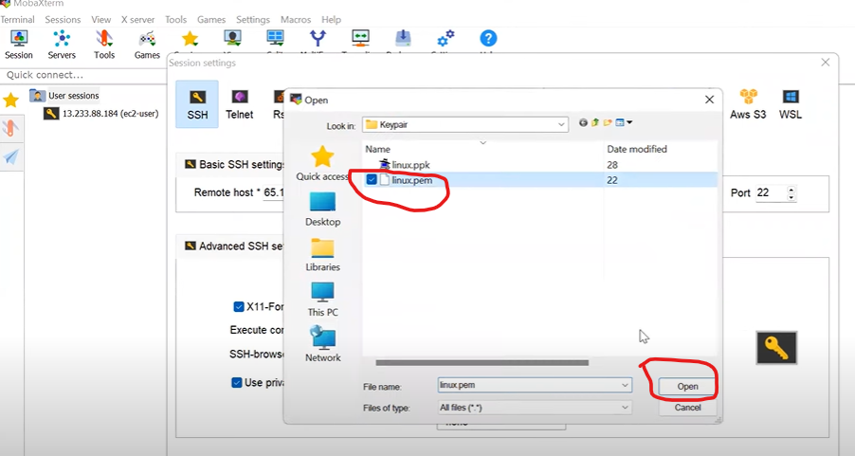

**35. NOW CLICK OK**

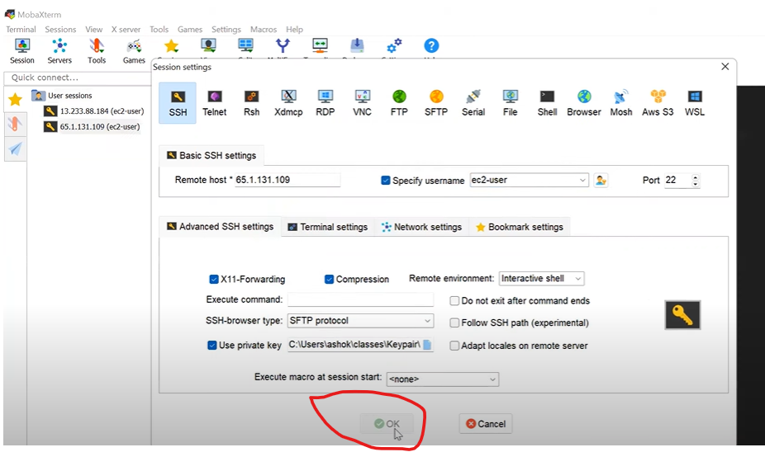

**36. NOW ITS CONNECTED TO THIS MACHINE (SAME AS THROUGH PUTTY)**

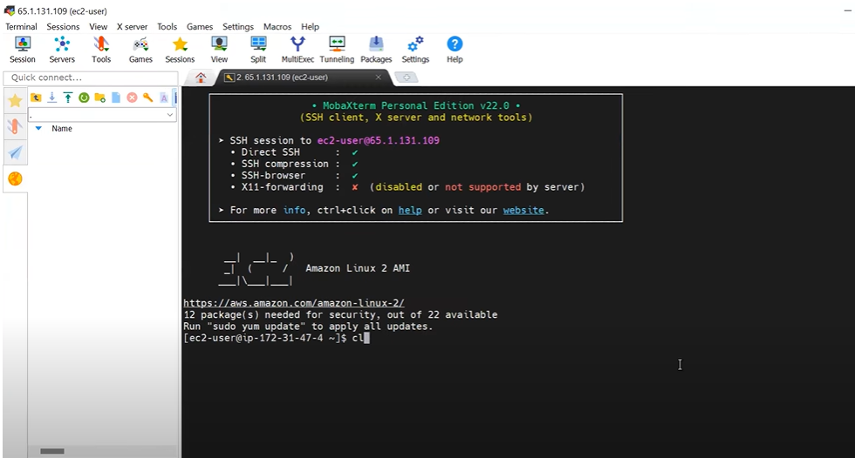

**37. NOW RUN COMMAND FOR UPDATE PACKAGES**

**$ SUDO YUM UPDATE**

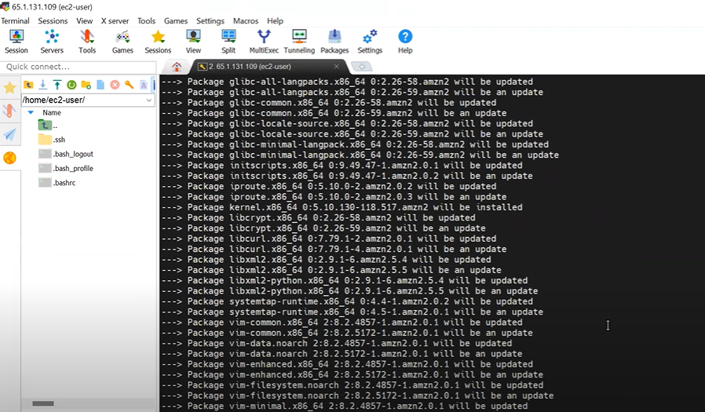

**38. NOW WE ARE GOING TO UPLOAD "JAR FILE" CLICK ON UPLOAD BUTTON**

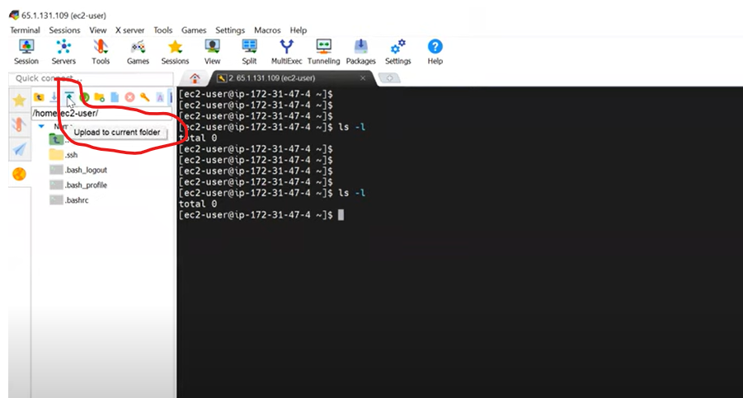

**39. SELECT THE JAR FILE LOCATION**

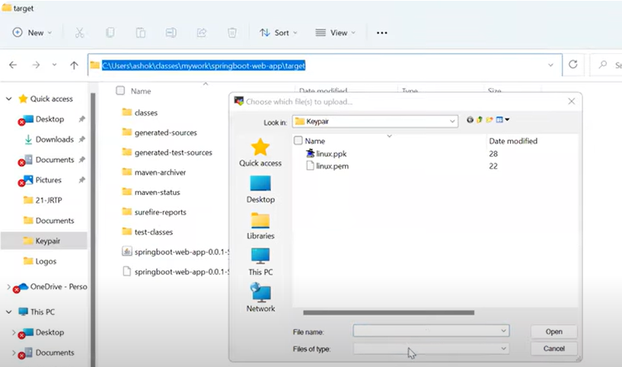

**40. SPRINGBOOT-WEB-APP-0.0.1-SNAPSHOT.jar**

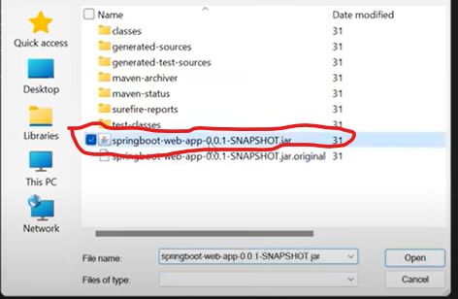

**41. NOW JAR FILE UPLOADE IN OUR WORKING DIRECTORY**

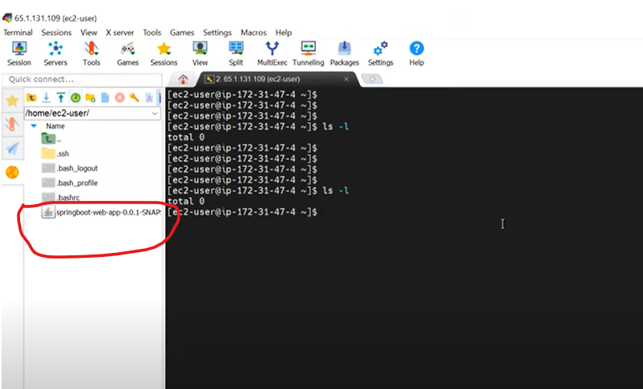

**42. NOW TYPE BELOW COMMAND ON YOUR TERMINAL**

**$ ls -l**

**# HERE SHOW JAR FILE**

**43. NOW RUN THIS JAR FILE**

**$ java -jar SPRINGBOOT-WEB-APP-0.0.1-SNAPSHOT.jar**

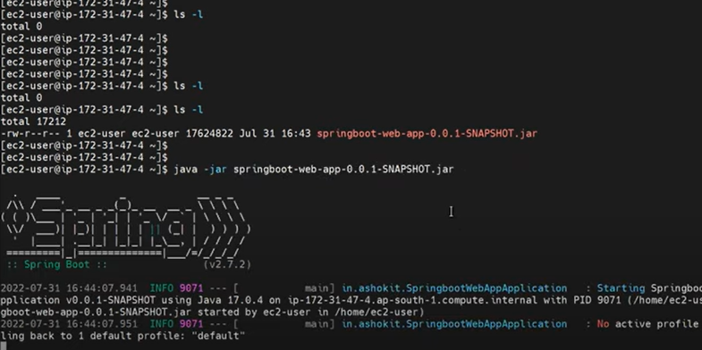

**# NOW JAR FILE IS EXECUTING & APPLICATION STARTED ON TOMCAT WITH PORT NUMBER 8080**

**# NOW COPY YOUR AWS PUBLIC IP AND PAST IN BROWSER WITH PORT NUMBER 8080 TO ACCESS SPRING BOOT TRHOUGH AWS CLOUD**

**FOR EXAMPLE : 65.1.13.109:8080 & HIT THE ENTER BUTTON**

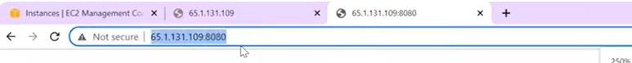

**THANKING YOU.......**

***MANIBHSHAN SINGH***